Name:

Effect of Distance on Brightness Lab

In this laboratory activity, you will use a bright grain of wheat lamp and a pinhole screen to compare the intensity of light at various distances from the light bulb. The goal will be to determine how the intensity of light changes with distance. But first, we will begin with a number of simple activities to help you develop a conceptual understanding of the effect that distance has on the apparent brightness of a light source.

- You have undoubtedly been a passenger in a car at night. Think about the approach of an oncoming car that has its headlights on. What happens to the apparent brightness of the car’s headlights as the car approaches you?

While the apparent brightness of the car’s headlights might change, the true brightness does not. True brightness is not affected by distance. It’s a measure of how much light the headlights (or any other light source) actually put out. It’s just like a 60-watt light bulb where the 60-watt statement is an indication of its true brightness. A 60-watt light bulb is a 60-watt light bulb no matter how far away you observe it.

- What do you think the relationship is between the apparent brightness of the oncoming car’s headlights and distance?

The closer the car, the ( brighter / dimmer ) the apparent brightness of the headlights.

- Take a flashlight and shine it on a wall. Now, move closer to the wall. Does the apparent brightness of the light on the wall appear to change as you move closer to it?

( yes / no )

- How does the apparent brightness of the light on the wall appear to change as you move away from the wall?

The light appears to get ( brighter / dimmer ).
- As you move first nearer and then farther from the wall, does the true brightness of the flashlight change?
( yes / no )

- When the circle of light on the wall gets brighter, is the same amount of light being cast into a smaller or larger area?

( smaller / larger )

- Complete the following statement:

Increasing distance between a light source and an observer will result in the light source appearing ( brighter / dimmer ).

- Explain in your own words why the above statement is so.

Now that you have a better understanding of the relationship between apparent brightness and distance, it is time to figure out the precise relationship using a grain of wheat lamp (Mini Mag flashlight with reflector removed – use no alternative) and a pinhole screen provided by your teacher.

Using clay to keep things in place, set up your Mini Mag flashlight horizontally. Ten (10) cm in front of the bulb, set up your pinhole screen. Place a meter stick beside your apparatus. Put the “0” point on the meter stick at the light bulb, and the screen at the 10cm position.

- Count the number of pinholes in the screen. How many are there? ____441______ This number gives and indication the number of “beams of light” coming from the light bulb and reaching the screen at this distance. Note that the number of beams is an indication of the amount of light present. 10 beams of light is 1/10 as time as bright as 100 beams of light and so one. You will note brightness dropping off with fewer beams.

Using a piece of index card the same size as the pinhole screen, count the number of beams of light striking this index card at different distances from the Min Mag flashlight bulb (not the screen). If you count 8 half beams, this would be equivalent to 4 whole beams and so on. Enter your data in the table found on the next page.

Distance of index card from the light bulb. | Number of beams counted on the index card.
10 cm | 441
12 cm | 306
15 cm | 196
20 cm | 110
30 cm | 49
40 cm | 28
50 cm | 18
60 cm | 12
70 cm | 9
80 cm | 7
90 cm | 5
100 cm | 4

Make a graph of number of beams on the index card versus distance of the index card from light bulb. If you did your work properly, your graph should look something like Fig. 1.
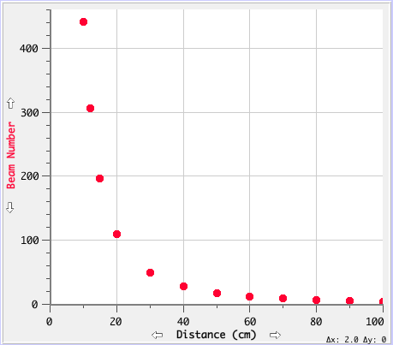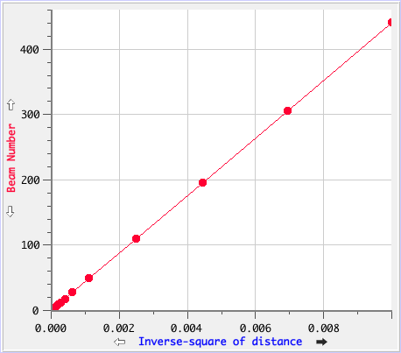
Figure 1 Figure 2
Now, square all the distances and invert them (e.g., 20² = 400; 1/400 = 0.0025). Then, re-plot Beam Number versus 1/Distance² (the inverse-square of the distance). If you did your work properly, your graph should look like Fig. 2.

- Using your second graph and your own words, state the relationship between the Beam Number (light intensity) and the inverse-square of the distance?

Effect of Distance on Brightness Lab: Print out or photocopy pinhole screens using overhead projector transparency material. Mount each grid into its own cardboard screen and stand upright using clay.

